SUMMERVILLE CREDIT UNION · CONSOLIDATED MEMBER GUIDE
Deactivate / Replace Card

Module: nFinia Digital Banking > Cards > Card Details > Deactivate / Replace Card
01 PRODUCT SUMMARY

The Deactivate / Replace Card feature lets you permanently disable a card or request a replacement when your card is lost, stolen, or damaged. Unlike freezing, deactivation is a permanent action — the card cannot be reactivated once deactivated. If you choose replacement, a digital version of the new card is made available instantly while a physical card is mailed to your address within 5 days.
The flow begins by describing what happened to your card and selecting an action: Deactivate Card only, or Request Replacement and Deactivate the current card. If replacement is selected, you choose whether to receive a physical card, confirm your mailing address, and set a PIN for the replacement card. Once submitted, the current card is immediately disabled.

At a Glance
Attribute | Detail
Module | nFinia Digital Banking > Cards > Card Details > Deactivate / Replace Card
Deactivate Only | Permanently disables the card — no replacement issued
Request Replacement | Issues a digital card instantly; physical card mailed within 5 days
PIN Required | A new 5-digit PIN must be set for the replacement card
Reversible | No — deactivation is permanent
Related Features | Freeze Card, Activate Card, Set PIN

02 KEY USE CASES

Use Case | Who Uses It | What They Do | Business Value
Report a lost card | Member whose card is lost or stolen | Selects Deactivate + Replacement, sets new PIN, submits | Instantly blocks the lost card and issues a digital replacement
Deactivate a damaged card | Member with a damaged card | Selects Request Replacement, confirms address, sets PIN | Replacement is issued digitally with physical card to follow
Permanently close a card | Member who no longer needs a card | Selects Deactivate Card only and confirms | Card is permanently disabled without issuing a replacement

03 STEP-BY-STEP GUIDE

Navigation: Log in to Summerville Credit Union online banking. From the Dashboard, click Cards in the top navigation, select your card, then click Deactivate / Replace Card.
Step 1 — Arrive at the Dashboard
After logging in, you land on the Dashboard showing your account balances and navigation links. Click Cards in the top navigation bar to access your card list, then select the card you want to manage.
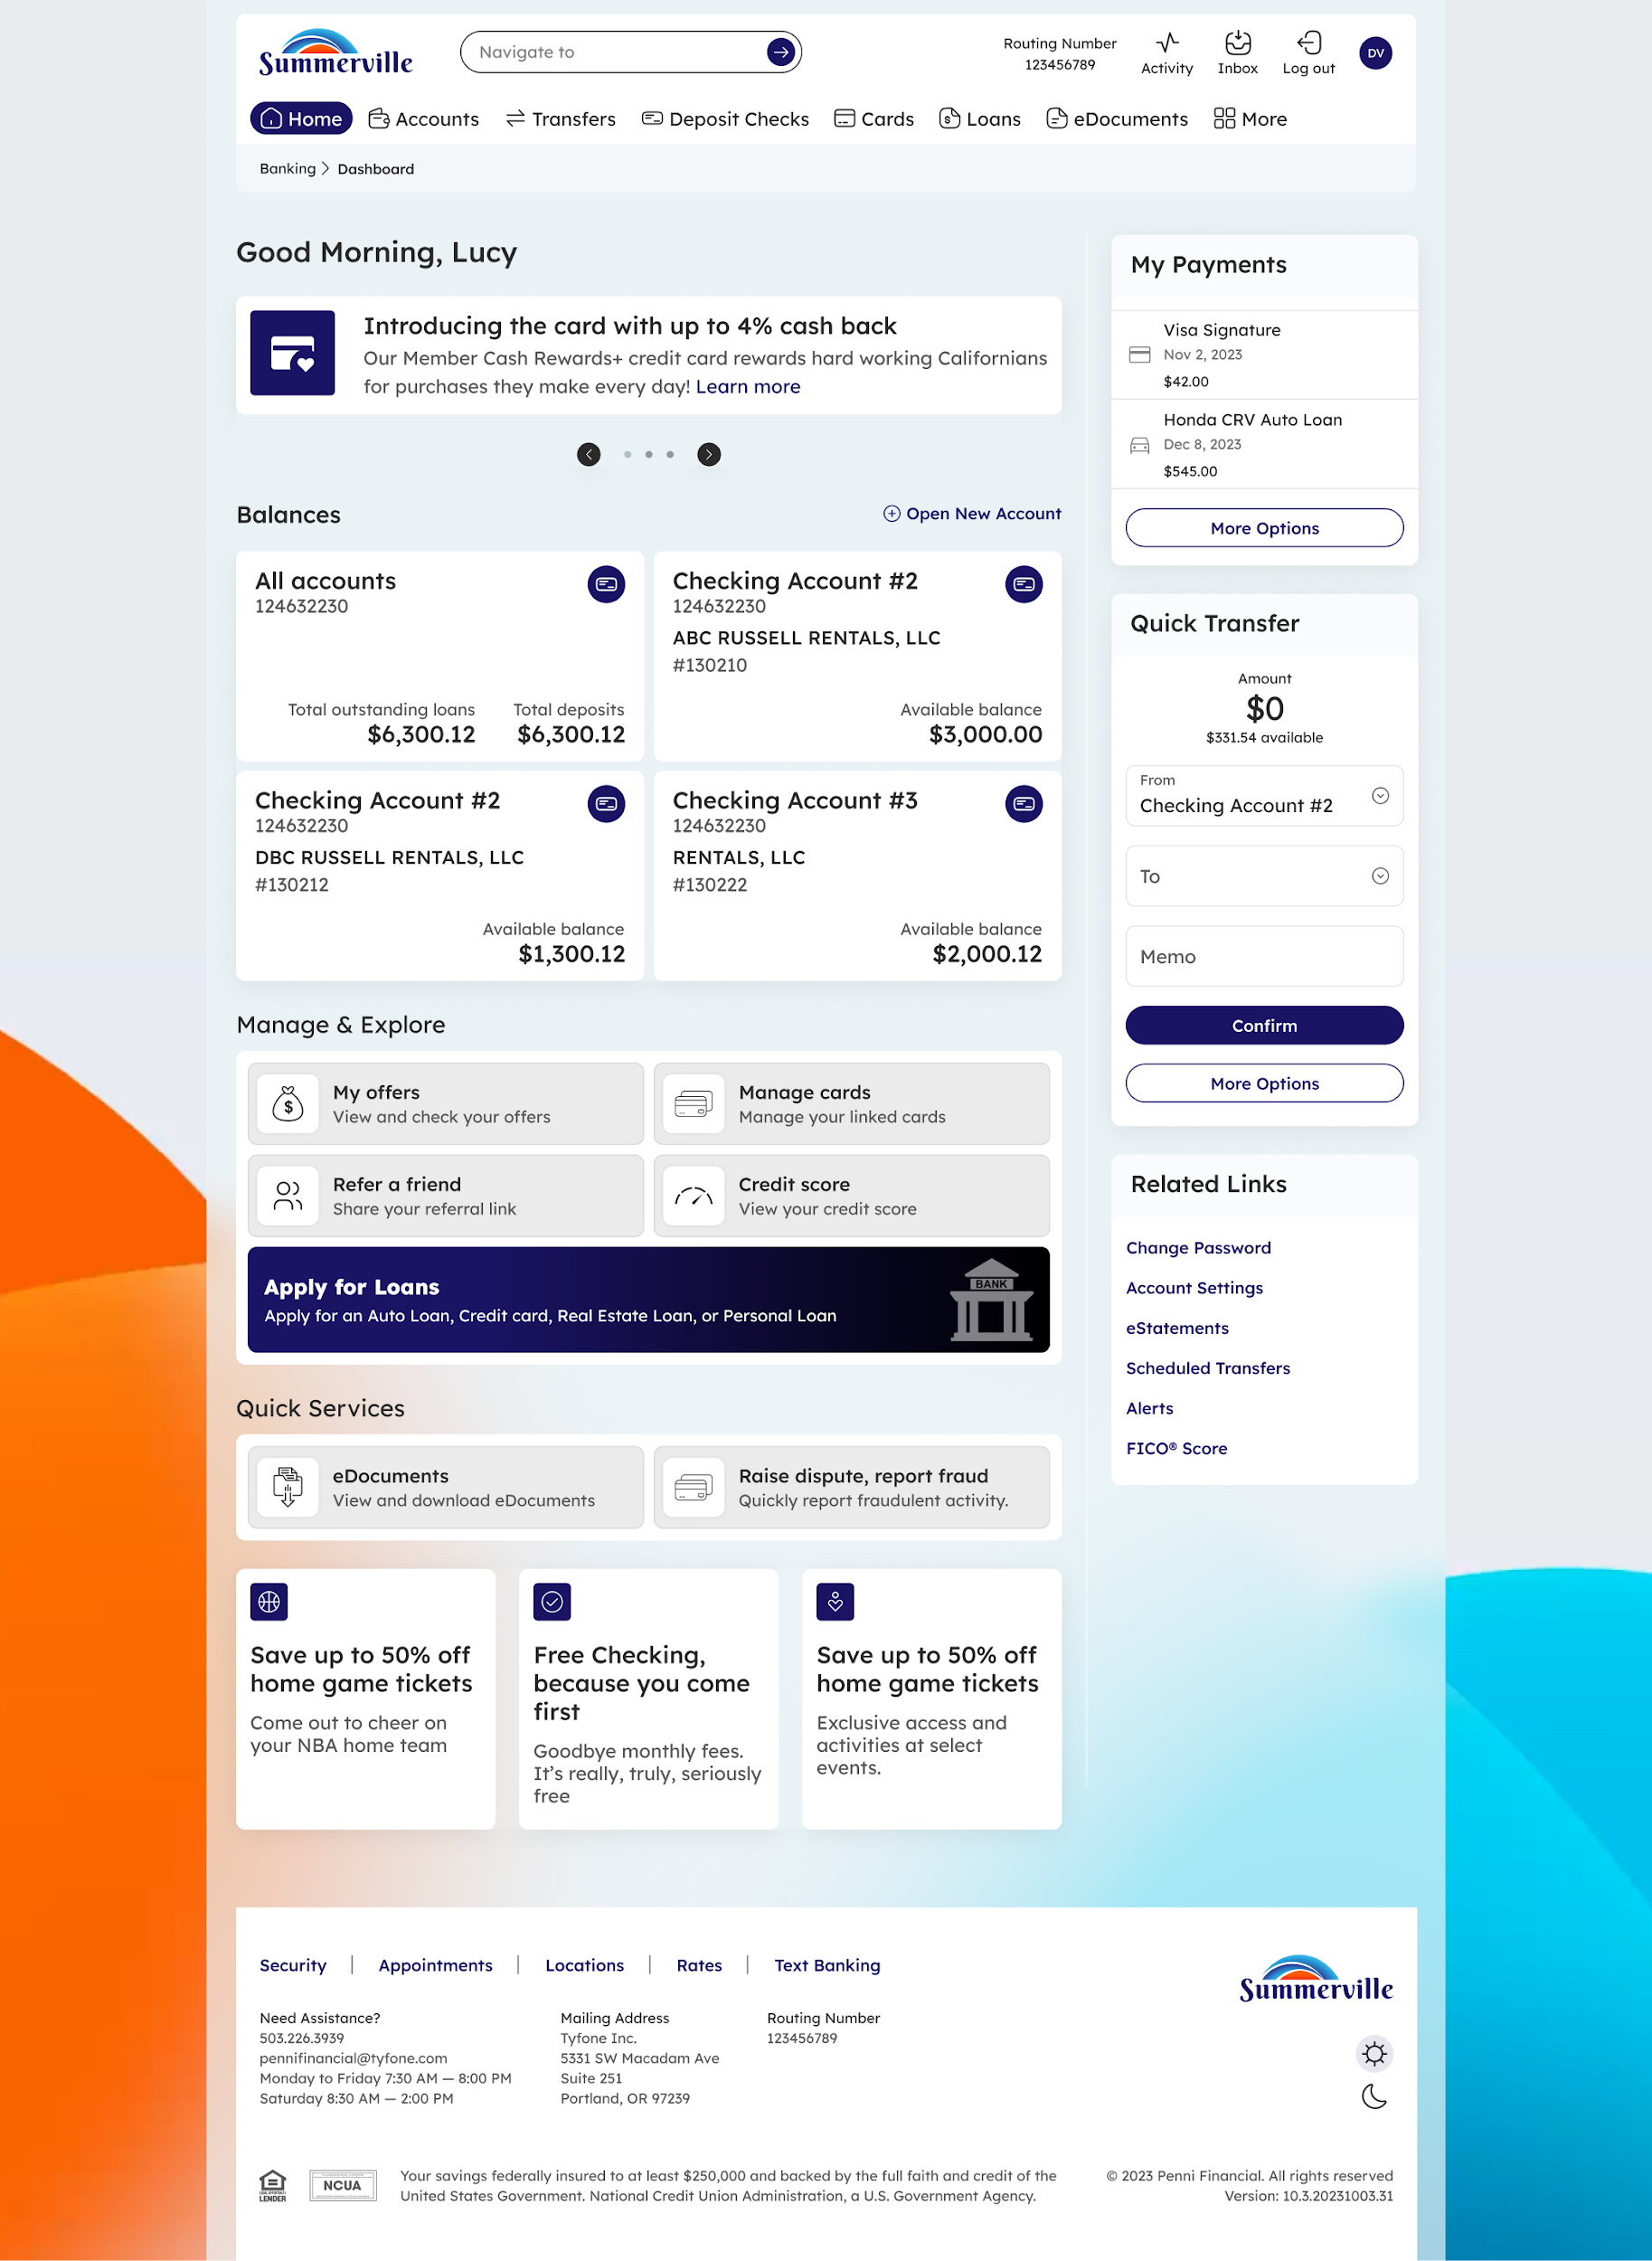
Step 1: Dashboard — navigate to Cards to begin
Step 2 — Select What Happened and Choose an Action
The Deactivate / Replace Card page opens. Use the "What happened to your card?" dropdown to describe the situation, and optionally add a description. Then select one of two options: Deactivate Card (permanent, no replacement) or Request Replacement & Deactivate Card (issues a new card and disables the current one). Click Continue to proceed.
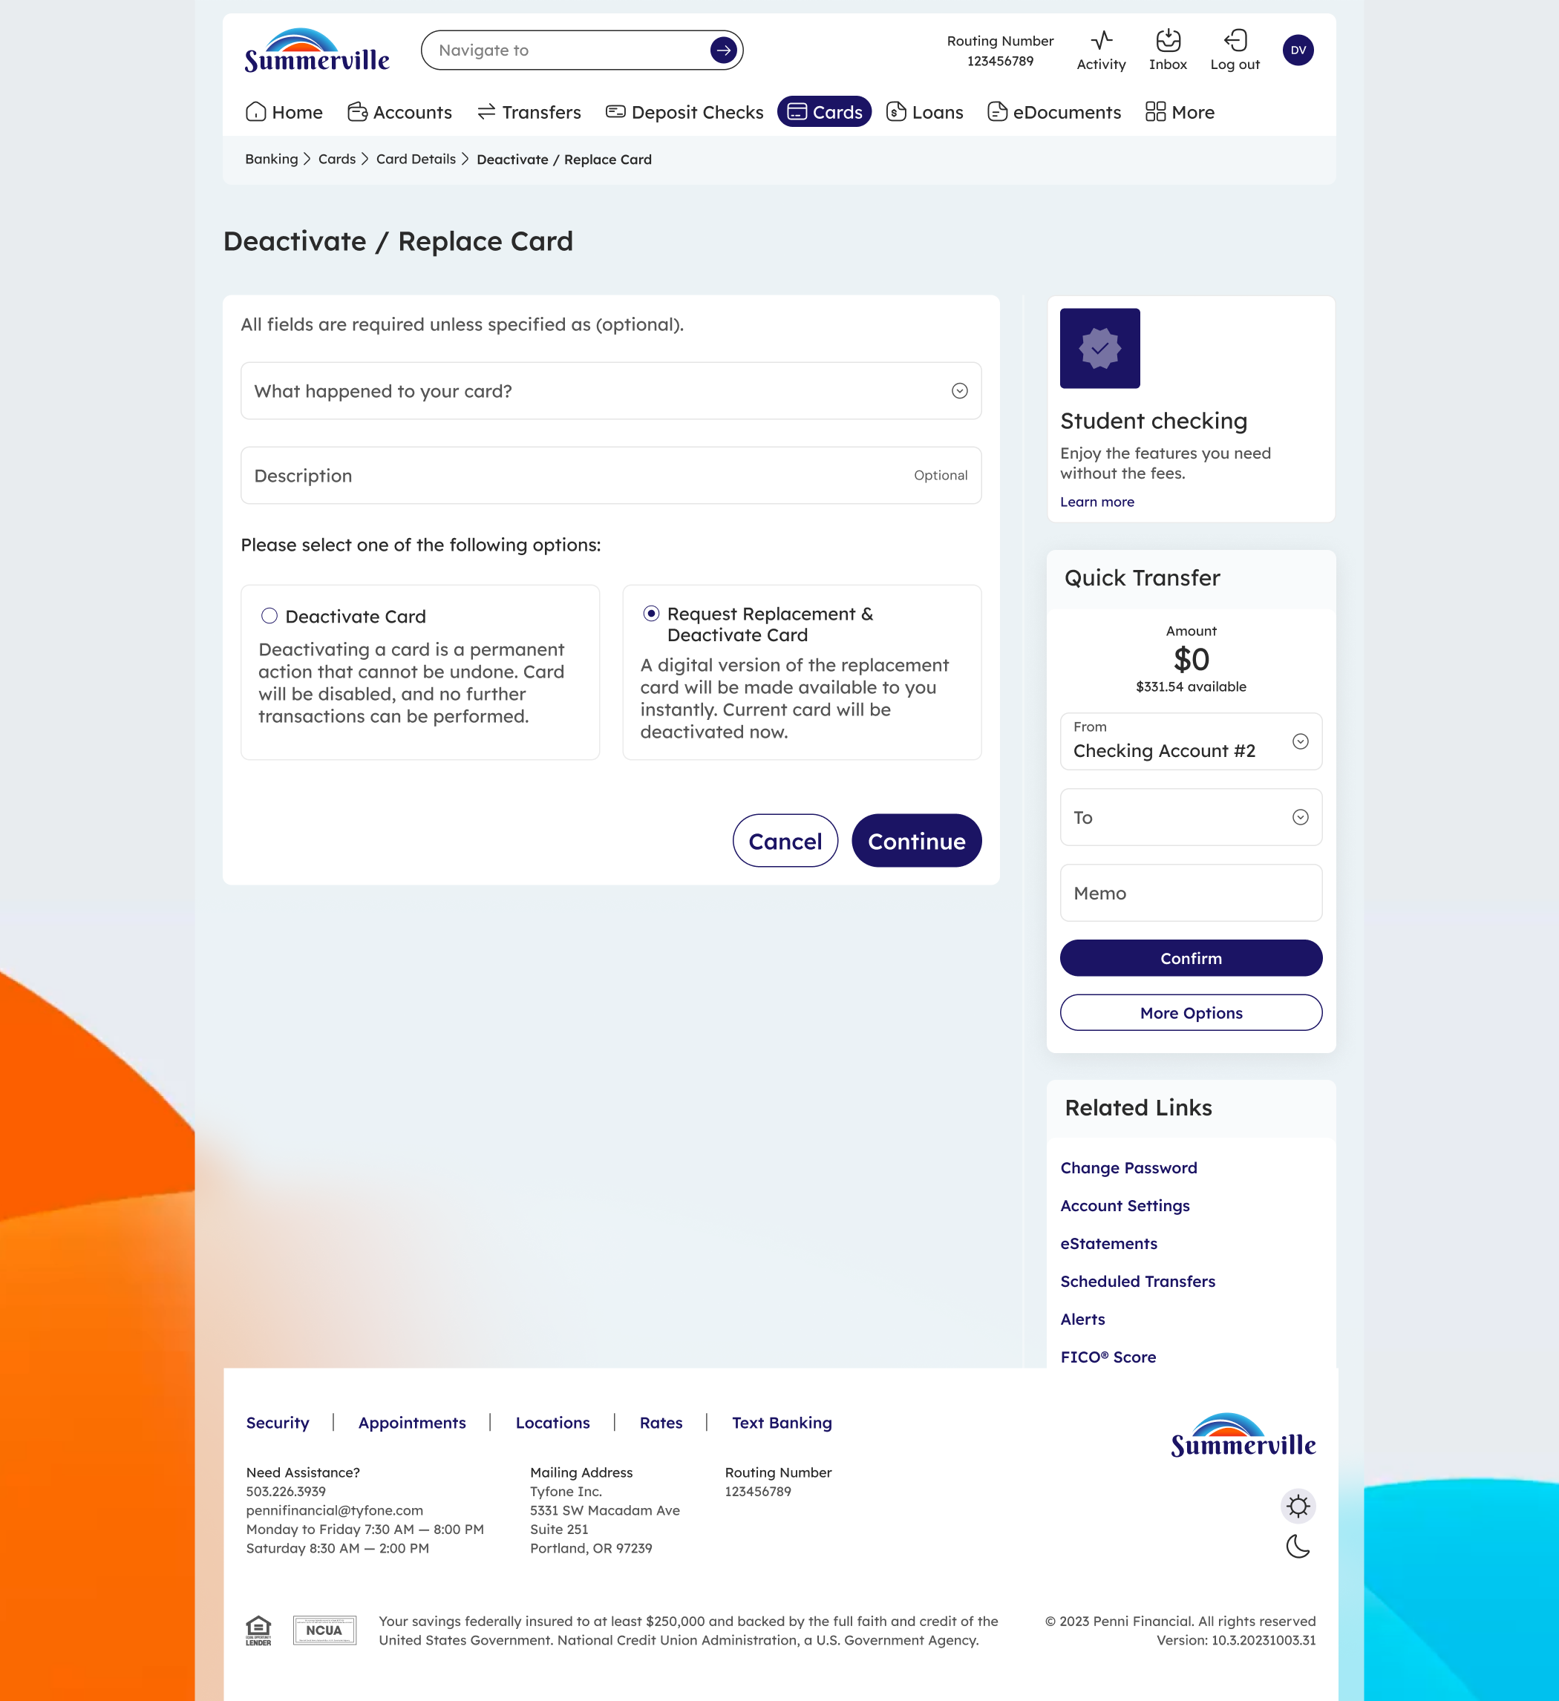
Step 2: Choose to deactivate only or request a replacement
Step 3 — Configure Replacement Card Details
If you selected Request Replacement, this screen asks whether you want a physical copy mailed to you. Choose Yes, Please to receive a physical card at your address on file (shown and editable via Change Address), or No, just digital to receive the digital card only. Enter and confirm a new 5-digit PIN for the replacement card, then click Request Replacement and Deactivate Card to submit.
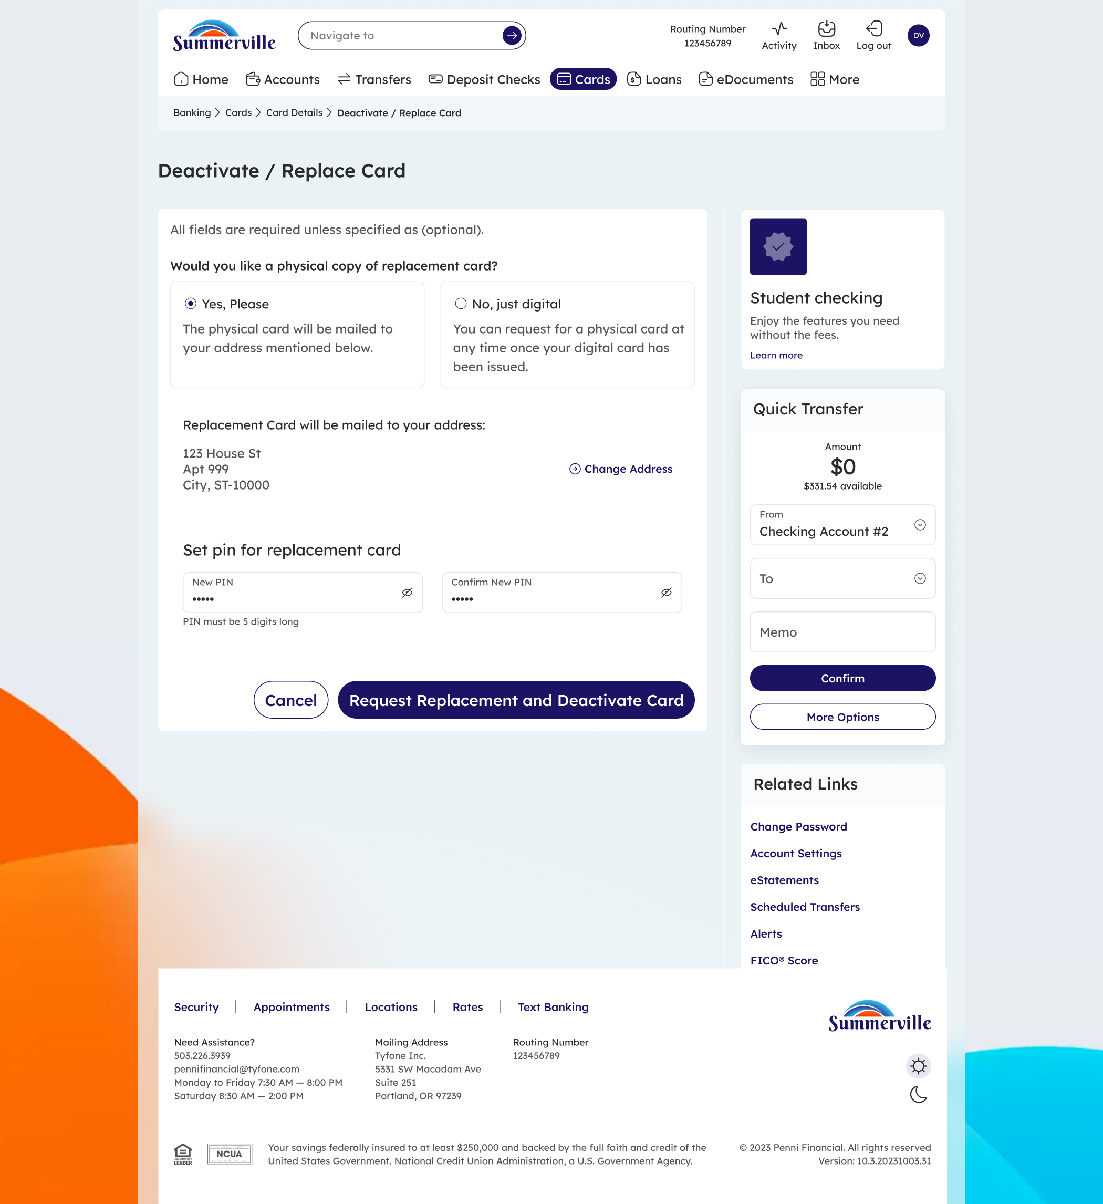
Step 3: Set your delivery preference and new PIN for the replacement card
Step 4 — Confirm Deactivation
A success screen confirms that your card has been deactivated. The message states that the card can no longer perform transactions. Click Go to Cards to return to your card list, or Go to Dashboard to return to the main banking dashboard.
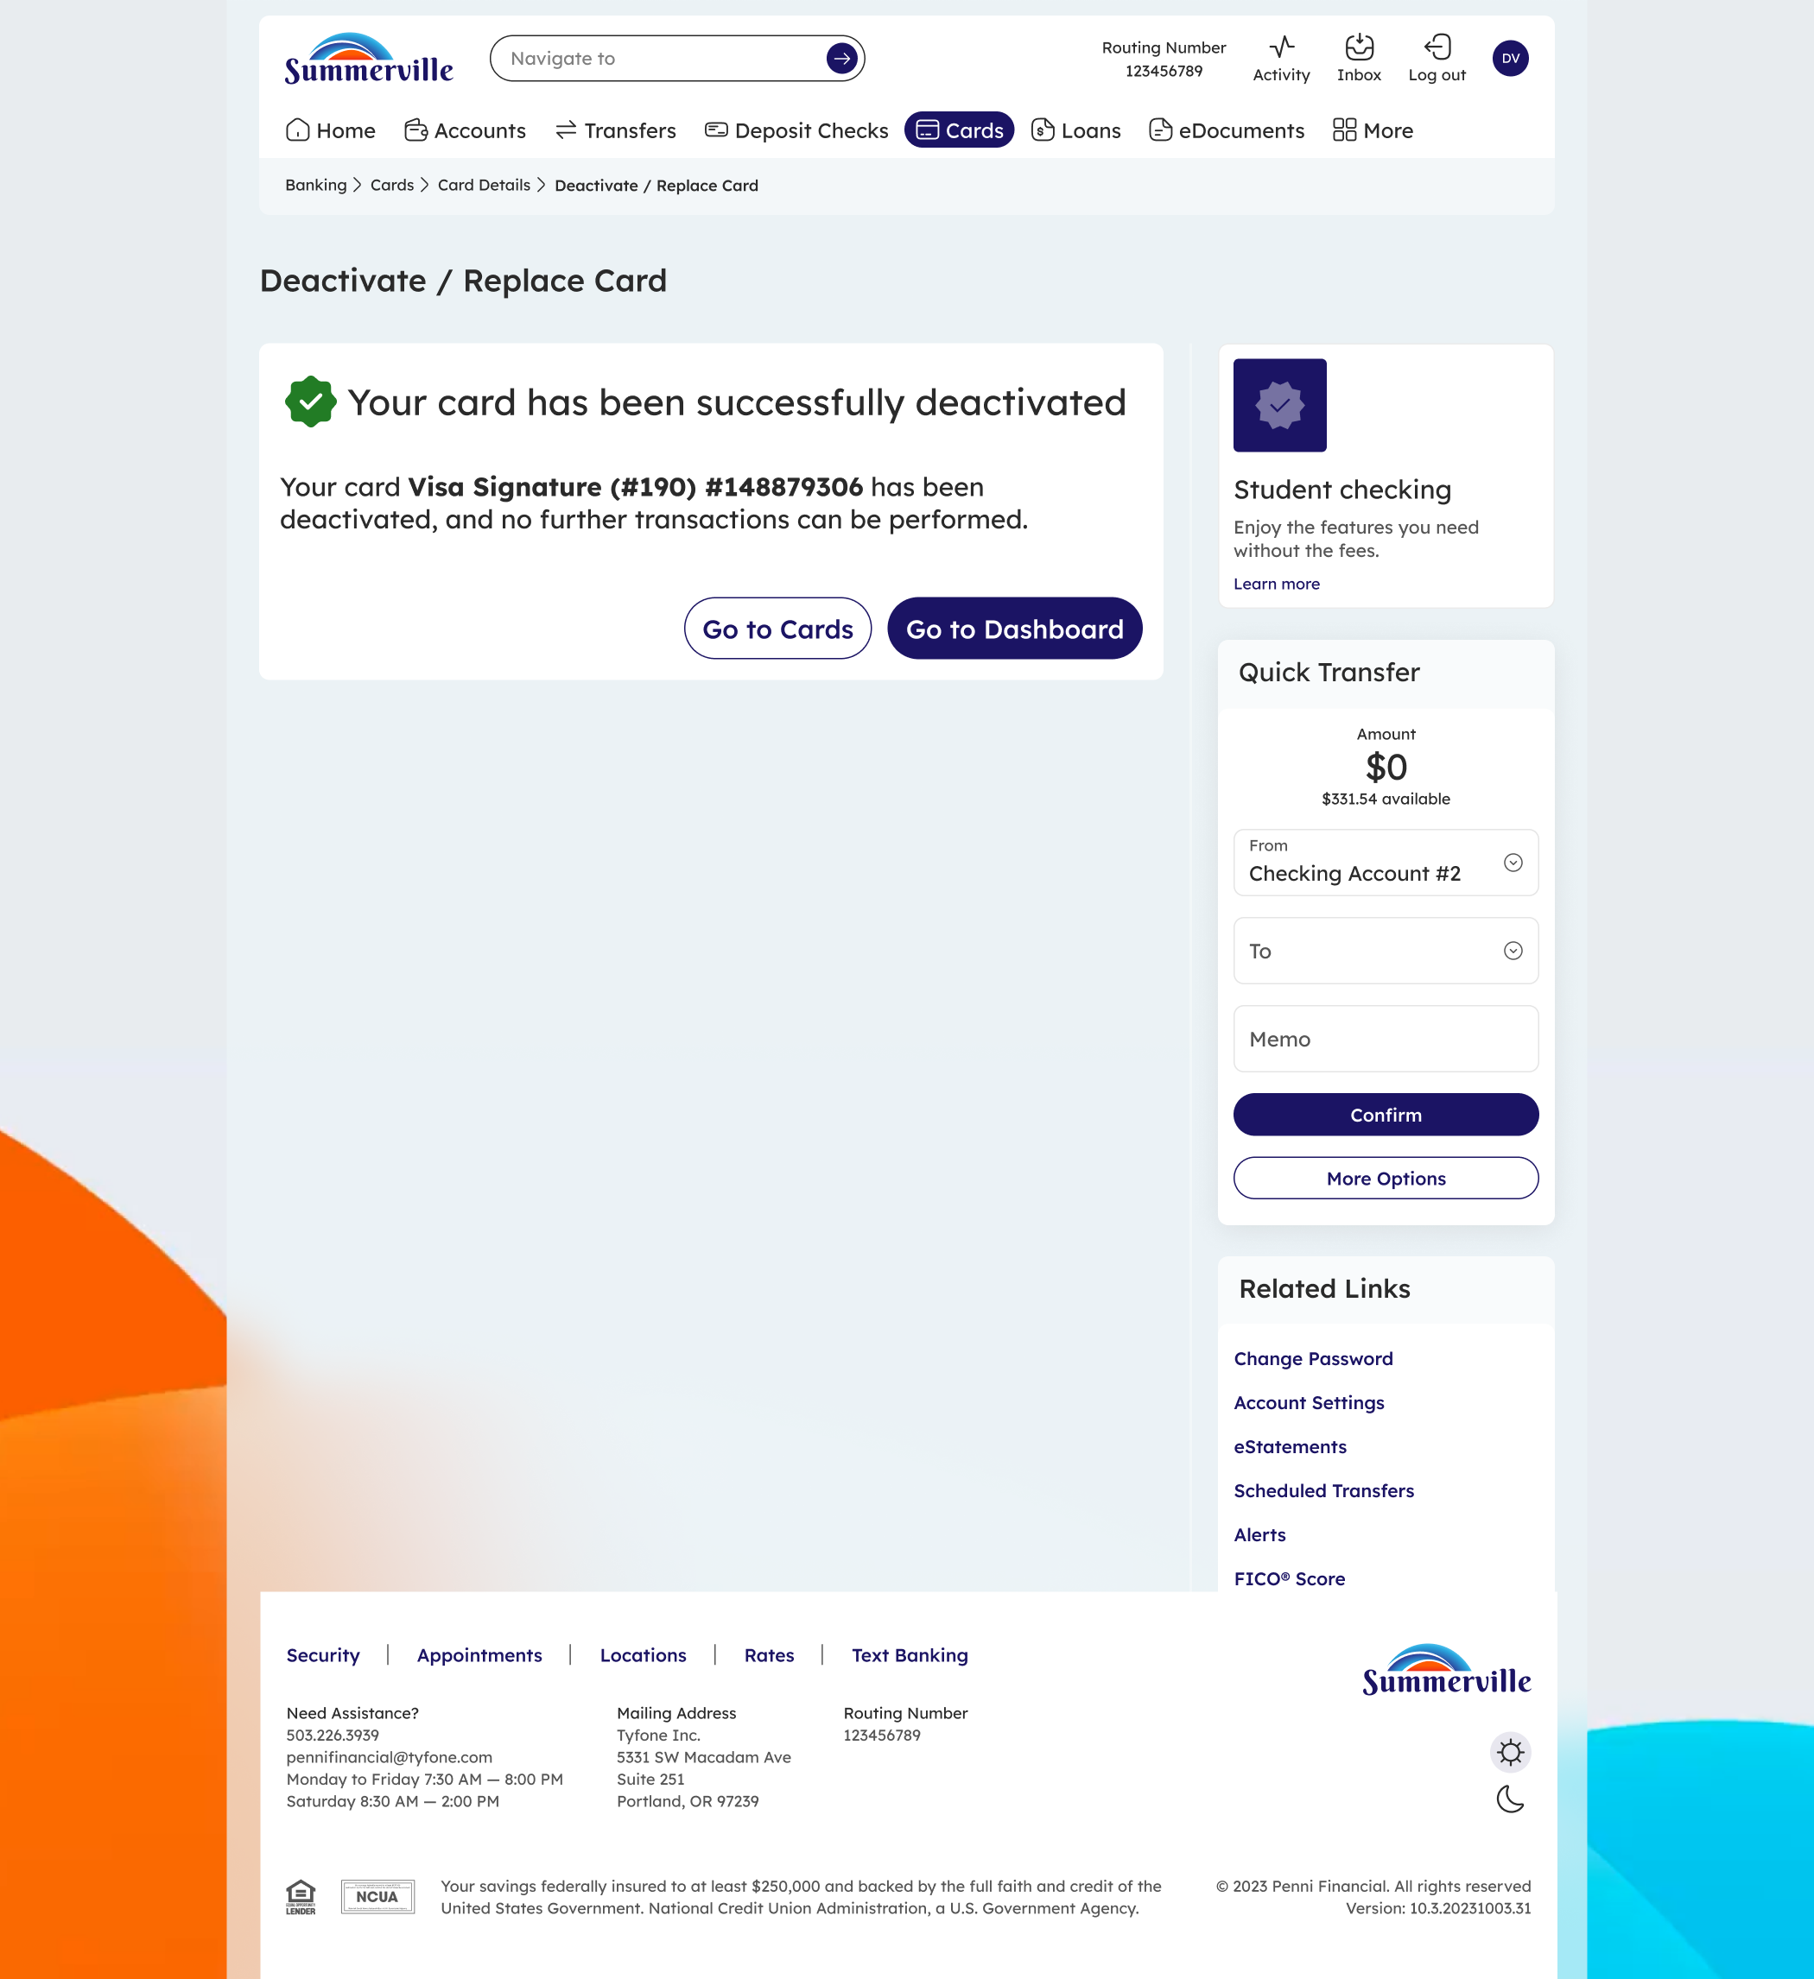
Step 4: Deactivation confirmed — the card is permanently disabled

